Word Statistics Project Documentation

Prepared for: Operating Systems 2

Faculty of Computers and Artificial Intelligence Helwan University

Project Title: Word Statistics (Project #2)

Team Members:

Kareem Omar 20230415

Malak Hossam 20230571

Abdelrahman Adel 20230312

Salma Kamal 20230256

Mariam Saeed 20230540

Toka Abdelaziz 20230142

Table of Contents

Project Description

What We Have Actually Done

2.1 System Architecture

2.2 Key Features Implemented

2.3 Extensions Beyond Requirements

2.4 Challenges and Solutions

Interface

Team Members and Roles

Code Documentation

5.1 Package : GUI

5.2 Package: filesystem

5.3 Package: processing

5.4 Package: core

5.5 Package: aggregation

5.6 Package: integration

5.7 Output Files

Conclusion

Project Description

This project implements Project #2: Word Statistics as specified in the Operating Systems 2 course guidelines. The application is a Java-based desktop program with a Graphical User Interface (GUI) that analyzes all .txt files in a user-selected directory (optionally including subdirectories up to 2 levels deep).

-For each file and the entire directory, it computes and displays:

Total number of words

Number of occurrences of "is", "are", and "you" (case-insensitive)

Longest and shortest word

-The program demonstrates operating systems concepts including multi-threading, real-time processing, file system monitoring, and thread synchronization.

-Implementation details:

Written entirely in Java

Uses Swing for the GUI

Multi-threaded using thread pool sized to available CPU cores

Exports results in TXT, JSON, and CSV formats

What We Have Actually Done

System Architecture

The project follows a clean, modular design with separation of concerns across six packages:

GUI – User interface

filesystem – Directory scanning and monitoring

processing – Per-file word analysis

core – Thread management and coordination

aggregation – Directory-level statistics and exports

integration – Main application launcher

Data flows from GUI → Scanner/Monitor → ThreadManager → Processing → Aggregation → GUI updates + Exports.

-Key Features Implemented

Directory selection with browse button and subdirectory checkbox

Real-time progress indication and status messages

Live-updating results table showing per-file statistics

Directory-level longest/shortest word summary

Multi-threaded processing with optimal thread count

Automatic export of results after processing

-Extensions Beyond Requirements

Implemented real-time file system monitoring using WatchService to detect file creation, modification, and deletion

Dynamic updates: GUI and exports refresh automatically when monitored files change

Debouncing mechanism to filter duplicate file events

Challenges and Solutions
Challenge | Solution
Keeping GUI responsive | All heavy work done in background threads; UI updates via SwingUtilities.invokeLater()
Thread-safe aggregation | Used StatsSynchronizer with synchronized methods
Duplicate file system events | Timestamp-based filtering with 100ms delay
Consistent file identification | Used absolute file paths as unique keys
Real-time directory summary | Observer pattern via RealTimeUpdateModel

Main Interface

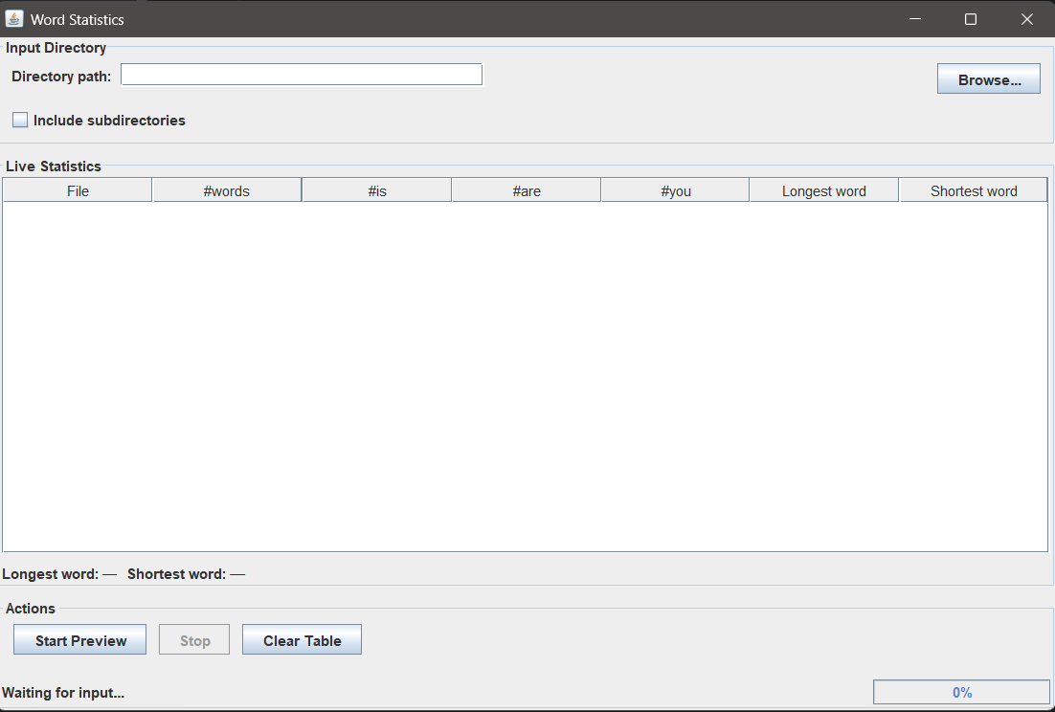

Team Members and Roles
Name | Role | Main Responsibilities
Kareem Omar | GUI Development | Designed and implemented all Swing components
Malak Hossam | Directory Scanner & Monitoring | Implemented scanning and real-time file system monitoring
Abdelrahman Adel | Thread Manager | Multi-threading, task distribution, and completion handling
Salma Kamal | File Processing | Per-file word analysis and statistics computation
Mariam Saeed | Aggregation & Export | Directory-level stats, thread safety, and file exports
Toka Abdelaziz | Integration + Documentation | AppLauncher integration, testing, and full documentation

All members contributed to code reviews, testing, and ensuring originality.

Code Documentation

Package: gui

MainWindow.java: Main frame

DirectoryChooserPanel.java: Directory input controls

OptionsPanel.java: Buttons and status

ResultsTable.java: Live statistics display

LiveUpdateHandler.java: Preview/demo mode

Package: filesystem

DirectoryScanner.java: Initial recursive scan

FileSystemMonitor.java: Real-time change detection

FileFilter.java: .txt file validation

ScanResult.java: Scan results holder

Package: processing

FileProcessor.java: Reads and analyzes individual files

KeywordsCounter.java: Counts "is", "are", "you"

WordAnalyzer.java: Tracks longest/shortest words

WordStatistics.java: Per-file stats container

FileProcessingTask.java: Callable for threading

Package: core

ThreadManager.java: Manages thread pool and tasks

TaskDistributor.java: Distributes files evenly

UpdateDispatcher.java: Coordinates GUI and aggregation updates

Package: aggregation

DirectoryStatsAggregator.java: Main aggregator and exporter

DirectoryStatistics.java & FileStatistics.java: Stats holders

StatsSynchronizer.java: Thread-safe updates

RealTimeUpdateModel.java: Observer for live updates

Package: integration

AppLauncher.java: Application entry point and wiring

Output Files

Generated in src/results/:

summary.txt – Human-readable summary

directory_statistics.json – Structured directory totals

file_statistics.csv – Detailed per-file data

Conclusion

The Word Statistics Analyzer successfully meets and exceeds the requirements of Project #2. It demonstrates strong understanding of multi-threading, concurrency, file I/O, and GUI programming in Java. The addition of real-time file monitoring provides a practical extension that enhances the application's usability and showcases advanced OS concepts.

Thank you for your evaluation.

